# Project Simple Calculator

Step-by-Step Simple Calculator Guideline

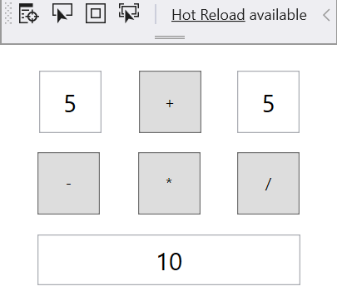

## Create New WPF Project

Open Visual Studio and create new "WPF App (.Net Core)" project

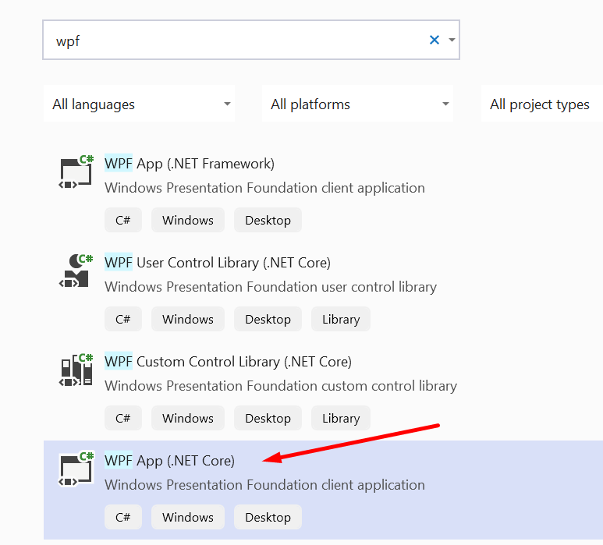

Write adequate name – MySimpleCalculator

.Net is going to create for you a runnable project, you can run it right away, although it is empty.

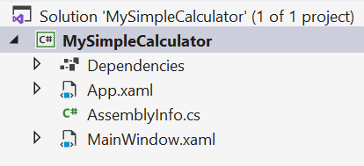

There are some files created, we are going to write in MainWindow.xaml

You can read what XAML is [here](https://en.wikipedia.org/wiki/Extensible_Application_Markup_Language)

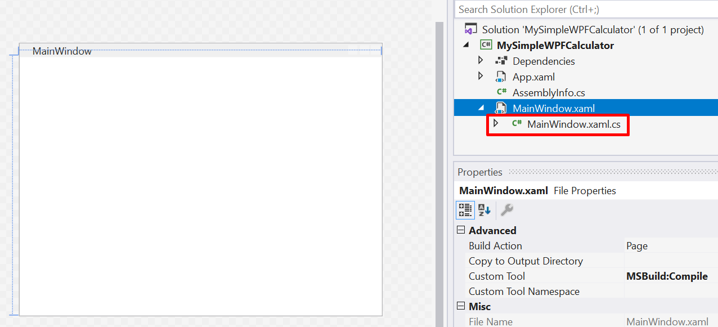

If you expand the MainWindow.xaml, you can see that there is a C# file -> MainWindow.xaml.cs

Here we are going to right our program in C#.

## Open Toolbox

Select MainWindow.xaml -> double click the file. You are going to see the blank main window of our desktop application.

On the sidebar to the left select "Toolbox", the Toolbox menu will open, containing various UI we can add to our window, like buttons, checkboxes, etc.

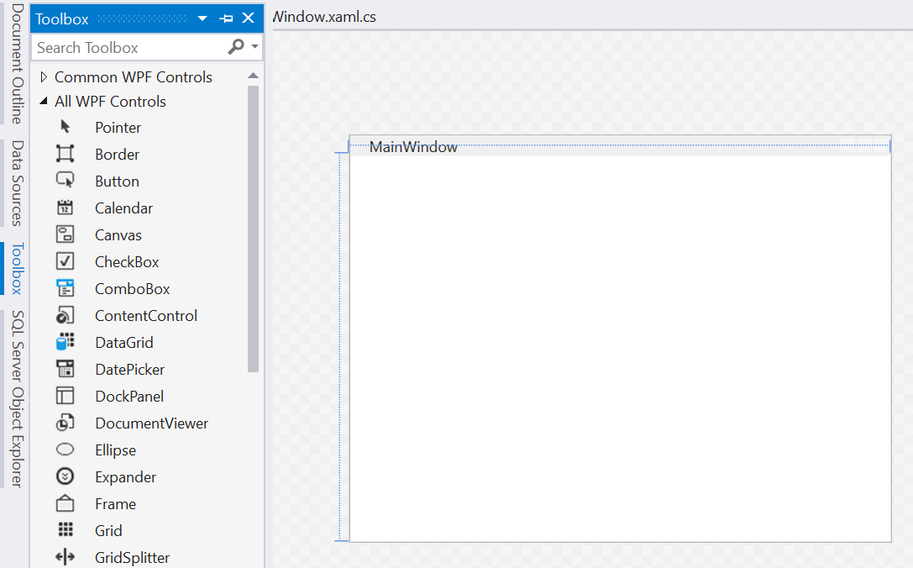

Or you can select – View -> Toolbox (Ctrl + W, X)

Now, lets Add some elements

## Add elements

We are going to create simple calculator, receiving two numbers and pressing a button, we are going to display the result. So, we will need input textbox for each number, a button for the operation, and another textbox for the display.

Select Textbox and drag a square on the Main window.

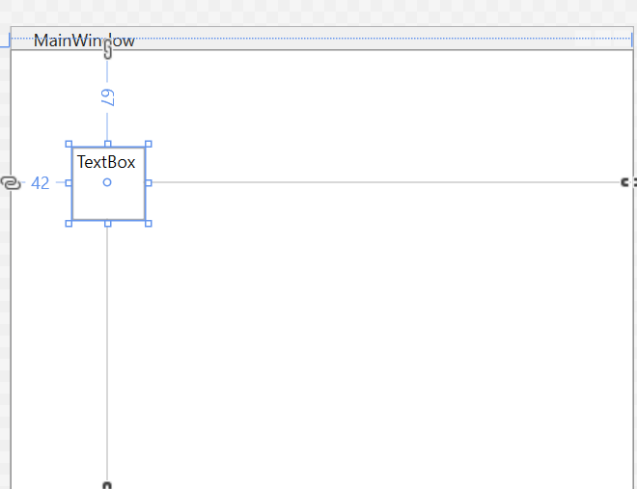

On the left side, below your Solution explorer, there is going to be a Properties window

Here, we can set all the properties for the selected element:

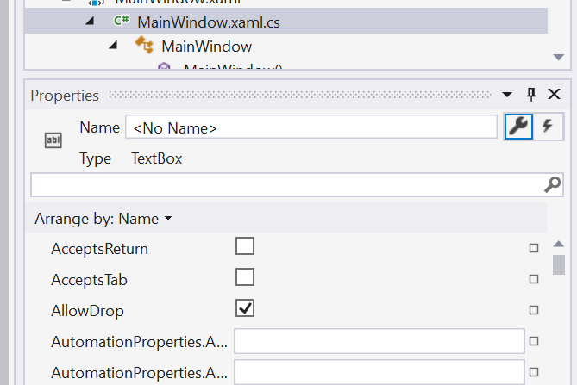

Lets give the textbox nice name, like FirstNumber

You can change the alignment of the text, the font size and etc.

If you hover on any property, you will get additional info, so you can understand what the property controls.

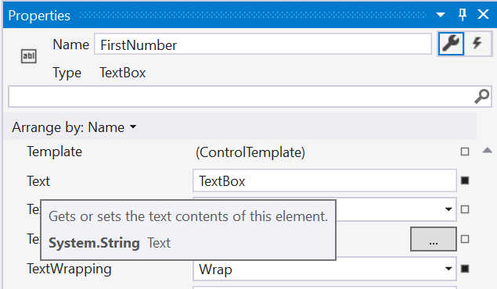

Now, lets add:

* Textbox – SecondNumber
* Button – AddButton
* Textbox – DisplayBox

Place them wherever you like, we are not going to concern ourselves with design and user experience for now.

You can also edit the VerticalContentAlignment and HorizontalContentAlignment of the textboxes, so the numbers appear in the middle of the box.

Note that the Displayed text on the button is in property "Content", not "Text", like the displayed text of a textbox.

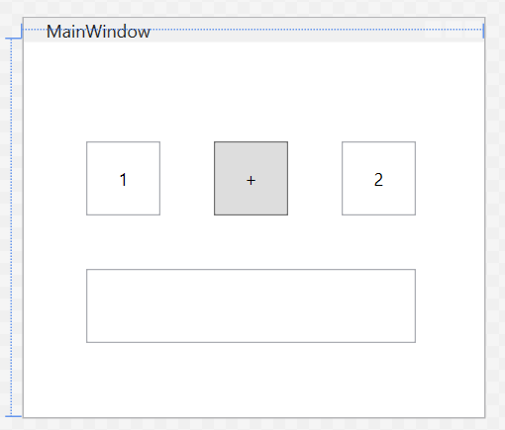

Now we can add the first functionality of our calculator, adding two numbers together.

## Implement Add Functionality

Double click on the button.

You are redirected in the MainWindow.xaml.cs file.

AddButton_Click was created for us. Here we can write our logic, for adding the two numbers.

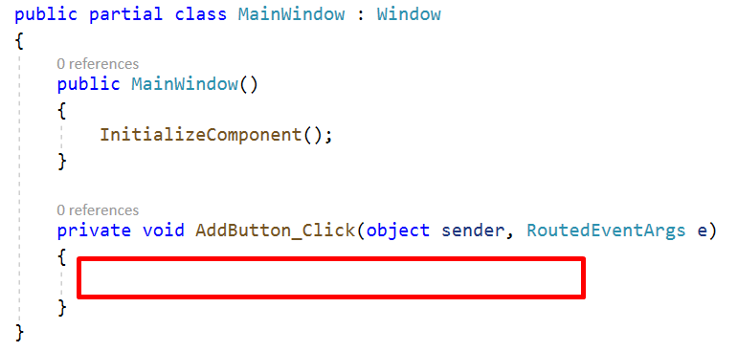

The code in AddButton_Click will be executed when the button AddButton is clicked.

But how can we receive the numbers that are entered in the two textboxes. Do you remember the names we gave to each element? Now we can use the name to take the element value.

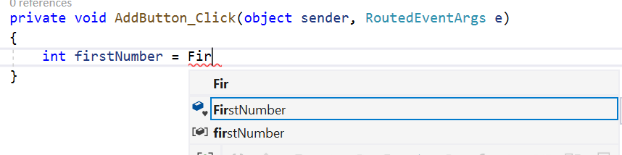

You need to select the property, that contains the value, for Textboxes it is Text.



Still, there is an error. That’s because the Text property is String, which we try to store in an int variable. We will need to parse the value.

Also, lets get the second number and calculate the sum.

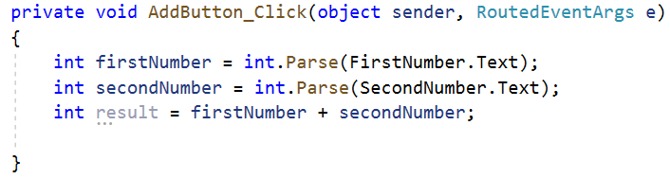

We have the result, we need only to display it.

As we can get the value of a TextBox, we also can set it. 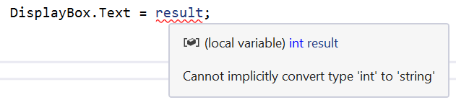

But because the property Text is String, we cannot assign integer to its value. We will need to convert it to string. There are many ways, we can concatenate the value of result with some empty string



Or we can use .ToString(), which converts the value of any variable to string.



Now we can test our Add button, run the project and check if it works correctly.

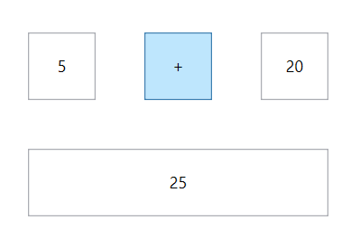

**Good Job!**

But our simple calculator works only with integers. You can change the datatype to double, so we can enter real numbers.

And we need to enter only valid numbers. Because we don`t have any validations yet.

Now, continue developing your calculator.

You can implement the other arithmetic operators.

Last, when you finish your calculator and you are happy with the result, lets Publish it and send it to our friends to brag.

## Publish

Right click on MySimpleCalculator project and press Publish.

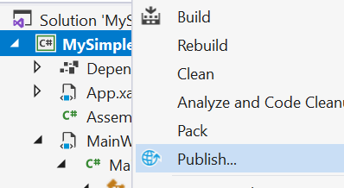

In the next menu just press Create Profile.

After that we need to edit some settings, so we get a nice .exe file in the end.

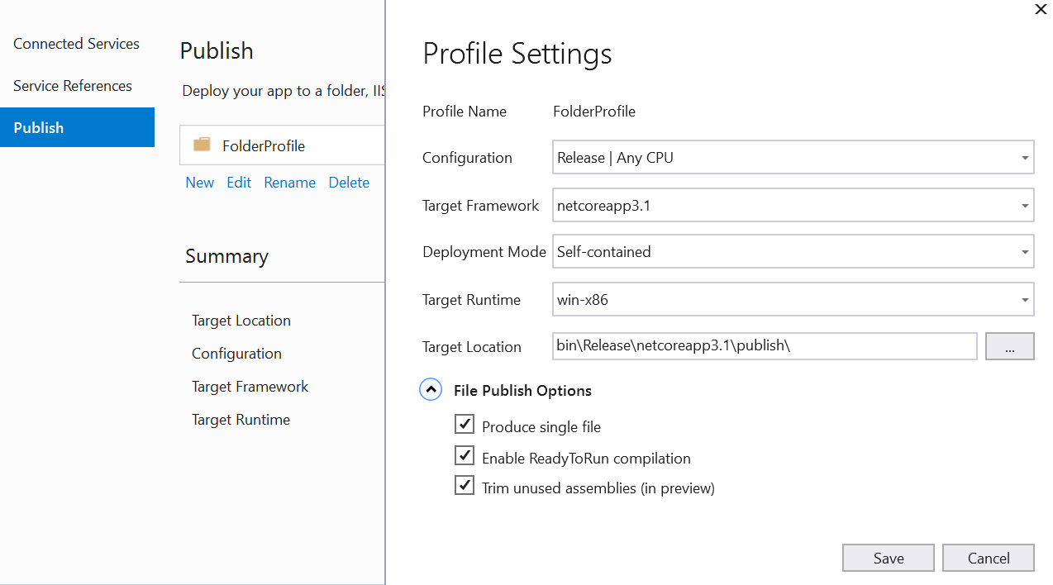

I`ve picked my settings and I am ready to press Publish button

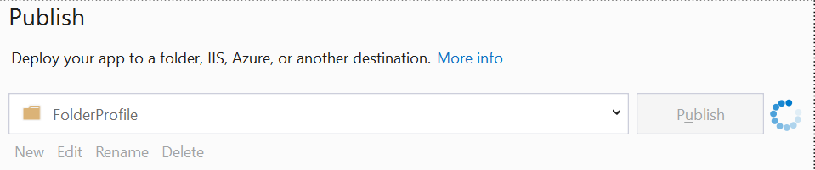

Now open the project folder, by clicking right click on the project -> open folder in explorer.

In the **"bin\Release\netcoreapp3.1\publish\"** folder you can find your MySimpleCalculator.exe

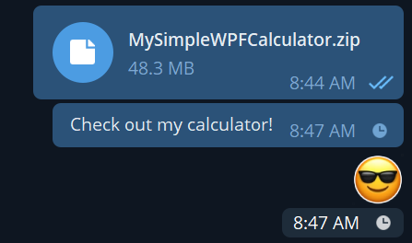

Have fun! Explore! Create!

Good luck!